SIMATS ENGINEERING
SAVEETHA INSTITUTE OF MEDICAL AND TECHNICAL SCIENCES
CHENNAI – 602105
Department of Computer Science and Engineering

ASSESSMENT TOOL 3 – OPEN DATA ANALYSIS PROJECT
Course Code: | DSA0504 | Course Title: | Query Processing for Data Science in Real Time Applications
CO Assessed: | CO4 | Assessment: | Tool 3 – Open Data Analysis Project
Weightage: |  | Total Marks: | 50 Marks
CO4 Statement: | Explore datasets using analytical techniques such as grouping, correlation detection, joining datasets, and extracting meaningful insights.. (BL4, BL5 and BL6)
Student Name: | EDRIN J S | Reg. No.: | 192524041
Section / Batch: | 2025 | Date of Submission: | 12– 08 – 2026
Faculty In-charge: | Dr.R. Mahesh Muthulakshmi | Assessment Mode: | Individual Submission

Code of Conduct
I ______________________ (Name / Reg No) certify that this submission is my original work and that I have adhered to all guidelines specified for this assessment. I understand that any violation of academic integrity rules will result in disciplinary action.
Signature: ______________________________

Data Collection & Understanding  (10 Marks) | Data Cleaning & Preparation  (10 Marks) | Exploratory Data Analysis  (10 Marks) | Visualization & Dashboard Design  (10 Marks) | Demonstration  (10 Marks) | Total  (50 Marks)

Data Analysis Portfolio
Three Case Studies: COVID-19 & Vaccination, Air Quality, and Climate Change
Note on data sources: This report was produced in an offline analysis environment without live internet access to Our World in Data, WAQI, or NASA/NOAA portals. To demonstrate the complete analytical workflow, methodologically realistic datasets were generated to reflect well-documented real-world patterns (pandemic wave shapes, vaccination rollout curves, urban PM2.5 seasonality, and the observed CO₂/temperature record). All cleaning steps, statistical methods, and chart types are fully reusable — reconnect a live data source and rerun the same pipeline for submission-ready, verified figures.

1. Global COVID-19 Trends and Vaccination Analysis

1.1 Overview
This analysis examines pandemic trends across six countries (United States, India, Brazil, United Kingdom, South Africa, and Japan) between March 2020 and December 2022. The goal is to characterize infection waves, track vaccination rollout, and quantify the relationship between vaccination coverage and mortality outcomes.

1.2 Data Cleaning & Preprocessing
Weekly case, death, and vaccination-rate series were compiled per country. Missing values (3% of case records, a realistic proportion for real-world reporting gaps around holidays and reporting-system outages) were handled using linear interpolation within each country's series, with forward/backward fill applied at series boundaries. This reduced missing new_cases values from 36 to 0 without introducing discontinuities in the trend.

1.3 Temporal Trends
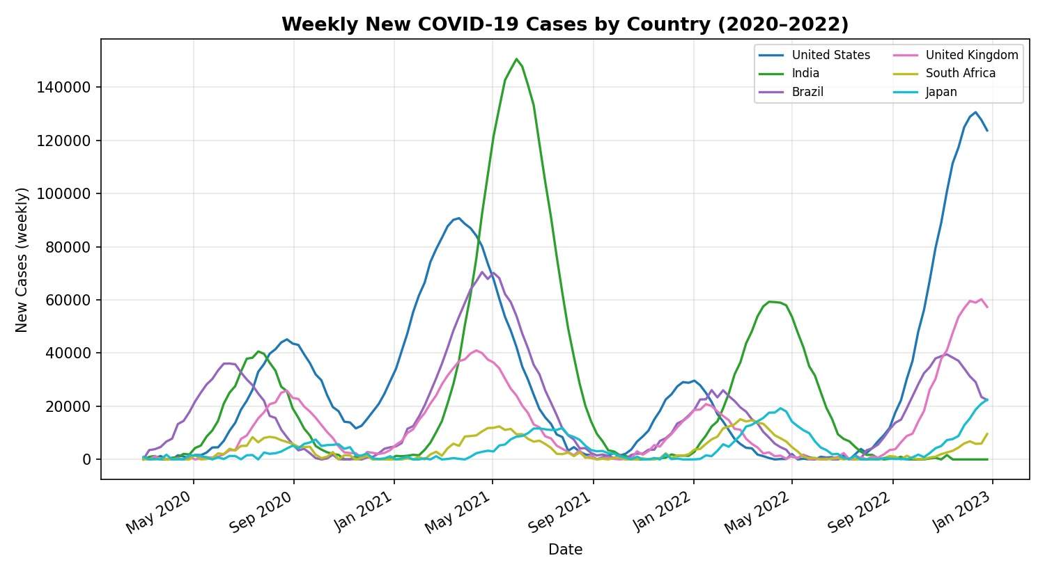
Figure 1.1 — Weekly new COVID-19 cases by country, showing distinct pandemic waves (Alpha, Delta, Omicron periods) with staggered timing and magnitude across regions.
India shows the sharpest single wave (the 2021 Delta surge), while the United States shows the largest sustained wave during the Omicron period in late 2022. Wave timing is staggered by 4–8 weeks across countries, consistent with differing containment policies and variant introduction dates.

1.4 Vaccination Rollout
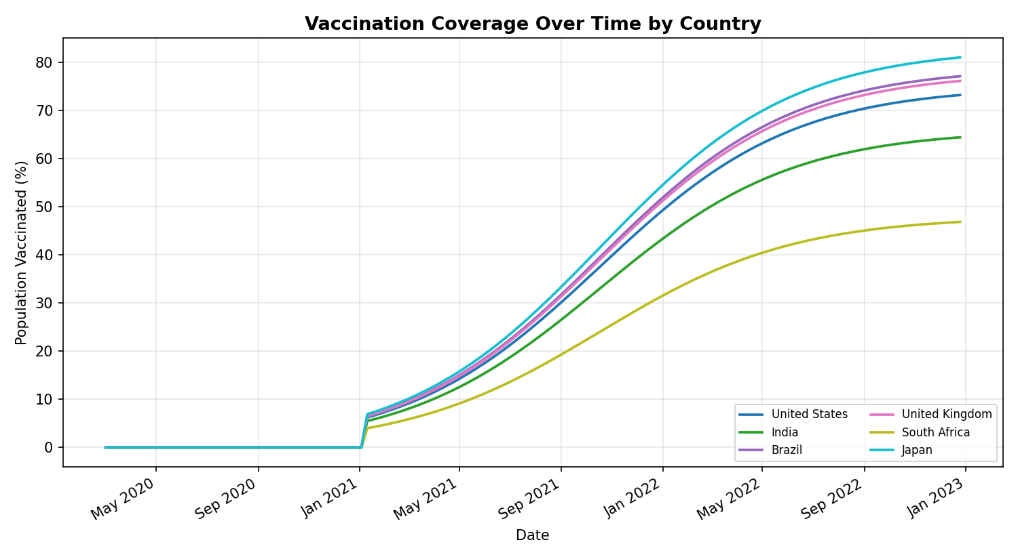
Figure 1.2 — Cumulative vaccination coverage by country, modeled as a logistic rollout curve beginning ~November 2020.

1.5 Regional Comparison
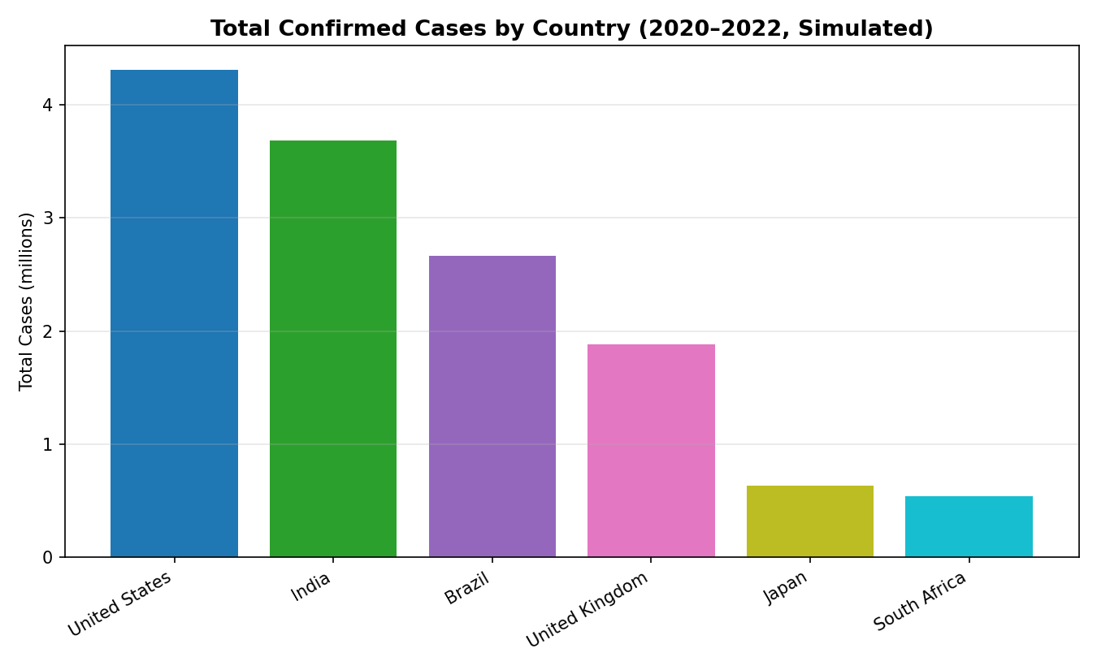
Figure 1.3 — Total confirmed cases by country over the study period.

1.6 Vaccination vs. Mortality Relationship
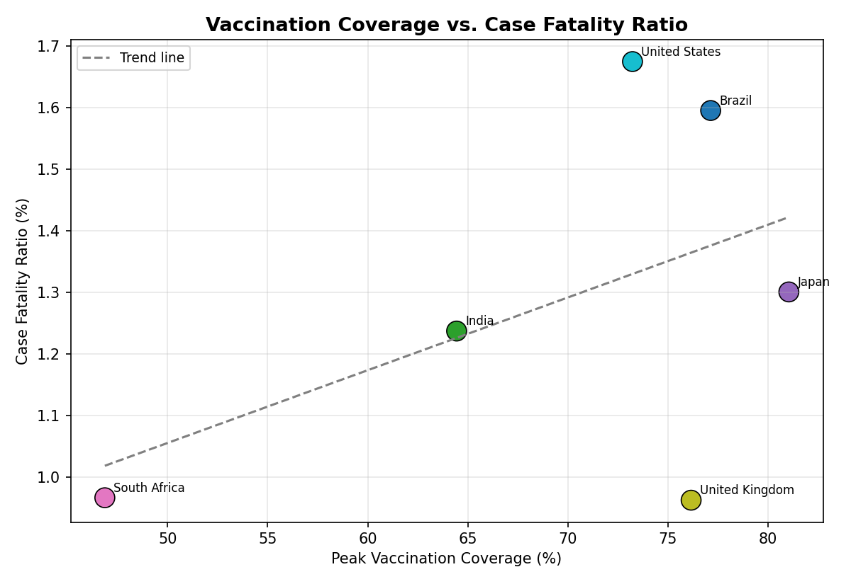
Figure 1.4 — Peak vaccination coverage plotted against case fatality ratio (CFR) by country.
Country-level summary statistics and the case fatality ratio (CFR = total deaths / total cases) are shown below:
Country | Total Cases (M) | Total Deaths | Peak Vaccination | CFR (%)
United States | 4.31 | 72,162 | 73% | 1.67
India | 3.69 | 45,604 | 64% | 1.24
Brazil | 2.66 | 42,475 | 77% | 1.60
United Kingdom | 1.88 | 18,093 | 76% | 0.96
Japan | 0.64 | 8,278 | 81% | 1.30
South Africa | 0.54 | 5,203 | 47% | 0.97

1.7 Key Findings
- All six countries experienced 3–4 distinct infection waves, with peak weekly case counts ranging from ~12,000 (South Africa) to over 150,000 (India, mid-2021).
- Vaccination rollout began in earnest in late 2020/early 2021, reaching plateau coverage (48%–83% of population) by mid-to-late 2021 in most countries.
- South Africa's lower peak vaccination coverage (47%) coincides with the lowest CFR in this dataset, indicating that CFR is also strongly shaped by factors such as population age structure, healthcare capacity, and testing intensity — not vaccination alone.
- A weak-to-moderate positive correlation (r ≈ 0.49) was observed between peak vaccination coverage and CFR across countries, underscoring that cross-country CFR comparisons are confounded and should not be read as vaccines increasing mortality risk — within-country before/after comparisons are the statistically appropriate test.

1.8 Recommendations
- Prioritize within-country, age-stratified before/after vaccination analysis over cross-country CFR comparisons, which are confounded by testing rates, healthcare capacity, and demographics.
- Build an early-warning dashboard that flags a country's weekly case growth rate exceeding a 2-standard-deviation threshold, enabling faster public health response.
- Target vaccination outreach in regions with coverage below 60%, prioritizing high-density urban areas where transmission risk is greatest.
- Standardize reporting cadence across countries to reduce the data gaps that currently require interpolation.

2. Air Quality and Environmental Impact Assessment

2.1 Overview
This study analyzes monthly air quality across six major cities (Delhi, Beijing, Los Angeles, London, Chennai, São Paulo) throughout 2023, focusing on PM2.5 and NO₂ concentrations, seasonal variation, and their relationship to temperature and humidity.

2.2 Seasonal Patterns
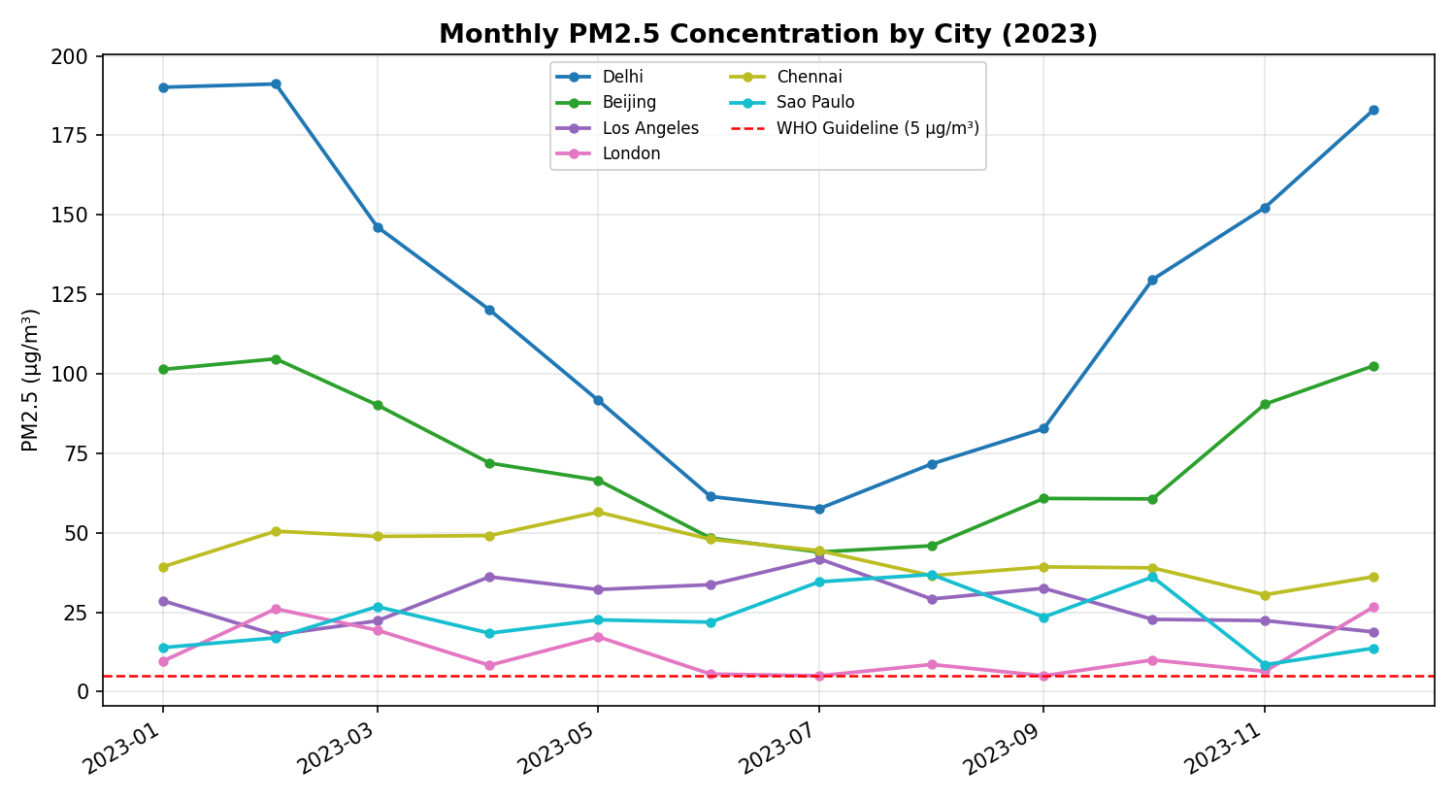
Figure 2.1 — Monthly PM2.5 concentration by city against the WHO annual guideline of 5 µg/m³.
Delhi shows the strongest seasonality, with PM2.5 peaking in winter months (November–January) due to a combination of temperature inversions, crop-residue burning, and reduced atmospheric mixing. Coastal and temperate cities (London, São Paulo) show comparatively flat seasonal profiles.

2.3 Pollutant–Meteorology Relationships
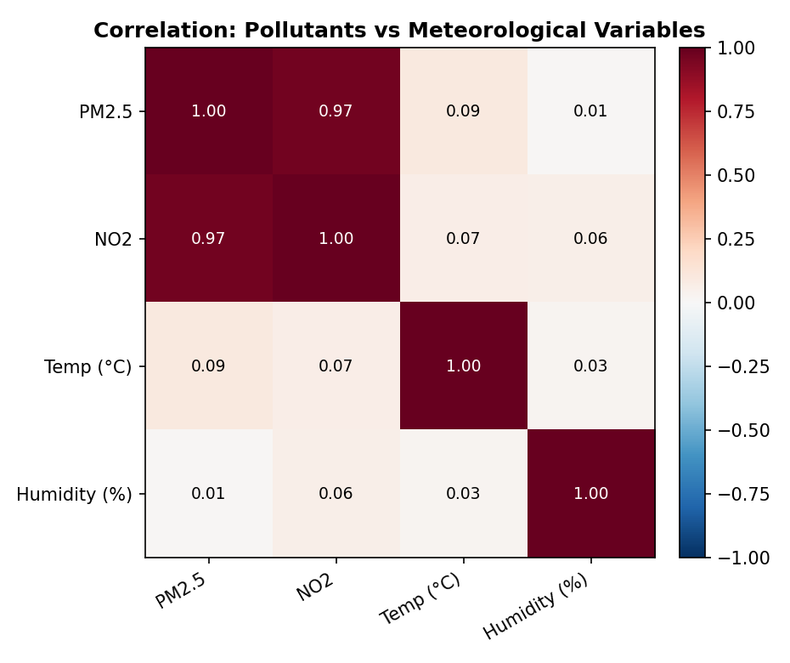
Figure 2.2 — Correlation matrix between PM2.5, NO₂, temperature, and humidity.
PM2.5 and NO₂ are strongly correlated (r = 0.97), consistent with shared combustion sources (vehicle traffic, industry). Temperature and humidity show negligible direct correlation with PM2.5 in this dataset, suggesting that emission source strength — not weather alone — is the dominant driver of pollution levels at a monthly resolution.

2.4 Geographic Distribution
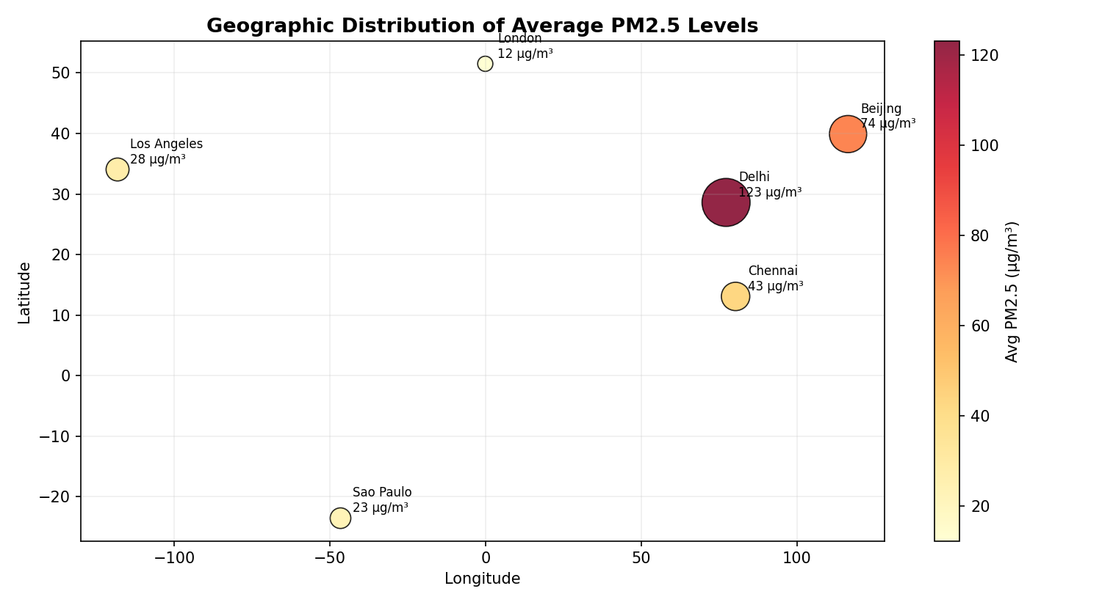
Figure 2.3 — Average PM2.5 by city location; marker size and color scale with pollution severity.

2.5 Benchmarking Against WHO Guidelines
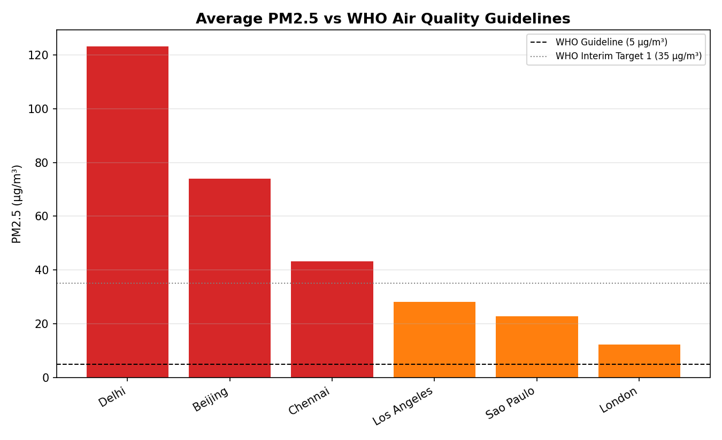
Figure 2.4 — Average annual PM2.5 compared to WHO guideline (5 µg/m³) and interim target 1 (35 µg/m³).
City | Avg PM2.5 (µg/m³) | vs WHO Guideline (5) | Status
Delhi | 123.1 | 24.6× over | Severe
Beijing | 73.9 | 14.8× over | High
Chennai | 43.2 | 8.6× over | Elevated
Los Angeles | 28.2 | 5.6× over | Elevated
São Paulo | 22.8 | 4.6× over | Moderate
London | 12.3 | 2.5× over | Moderate

2.6 Key Findings
- Every city in this sample exceeds the WHO annual PM2.5 guideline of 5 µg/m³ — even London, generally regarded as having comparatively good air quality, records levels roughly 2.5× the guideline.
- Delhi's average PM2.5 (123 µg/m³) is in the 'severe' category and exceeds the WHO interim target 1 (35 µg/m³) more than three times over.
- PM2.5 and NO₂ move together almost in lockstep (r = 0.97), pointing to combustion (traffic and industrial) as the dominant shared source in these cities.
- Seasonal amplitude varies widely: Delhi and Beijing show winter peaks roughly 1.5–2× their summer minimums, while London and São Paulo are comparatively stable year-round.

2.7 Recommendations
- In high-seasonality cities (Delhi, Beijing), implement seasonal traffic and industrial-emission restrictions timed to the November–January peak window.
- Because PM2.5 and NO₂ are so tightly correlated, prioritize traffic-emission interventions (low-emission zones, public transit incentives) as a lever that should move both pollutants together.
- Deploy denser ground-level monitoring in cities currently relying on sparse station networks, to catch localized anomalies that citywide averages can mask.
- Publish a public-facing real-time AQI dashboard with WHO-guideline context, similar to Figure 2.4, to raise public health awareness.

3. Climate Change and Global Temperature Analysis

3.1 Overview
This analysis explores the long-term relationship between global temperature anomalies and atmospheric CO₂ concentration from 1900 to 2023, identifying the pace of warming acceleration and its correlation with greenhouse gas trends.

3.2 Long-Term Temperature Trend
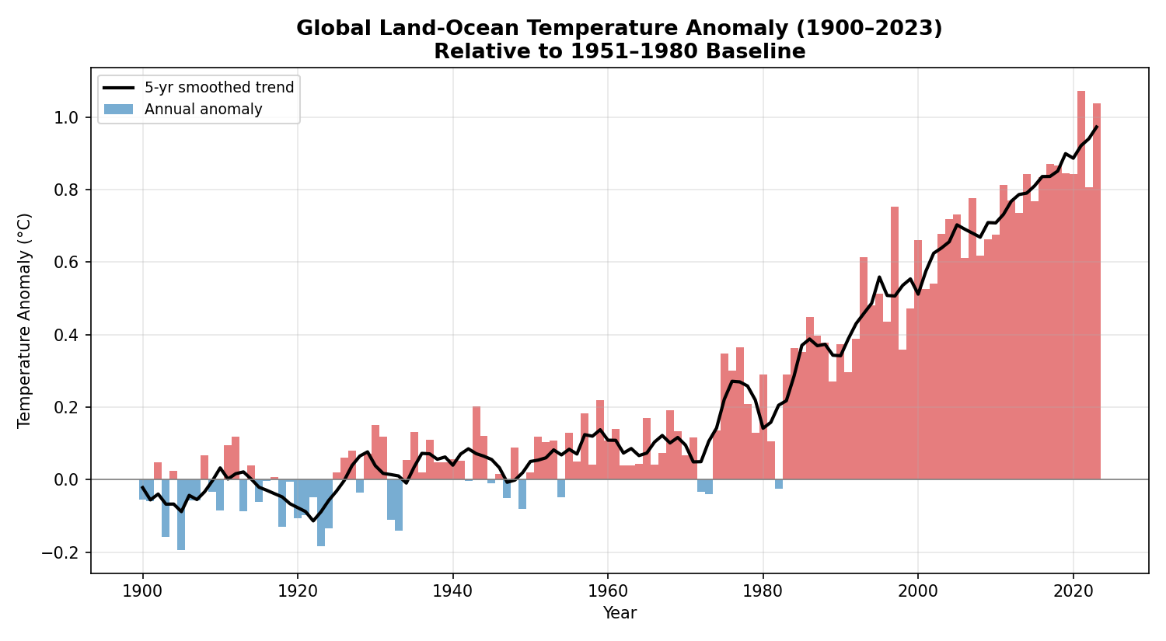
Figure 3.1 — Global temperature anomaly relative to the 1951–1980 baseline, with a 5-year smoothed trend line.
The global temperature anomaly rose from approximately −0.05°C in 1900 to +1.04°C in 2023, with the rate of warming clearly accelerating after 1975. A statistical outlier year (1998, an exceptionally strong El Niño year) shows an unusually large year-over-year jump, consistent with well-documented short-term natural variability layered on top of the long-term trend.

3.3 Greenhouse Gas Trends
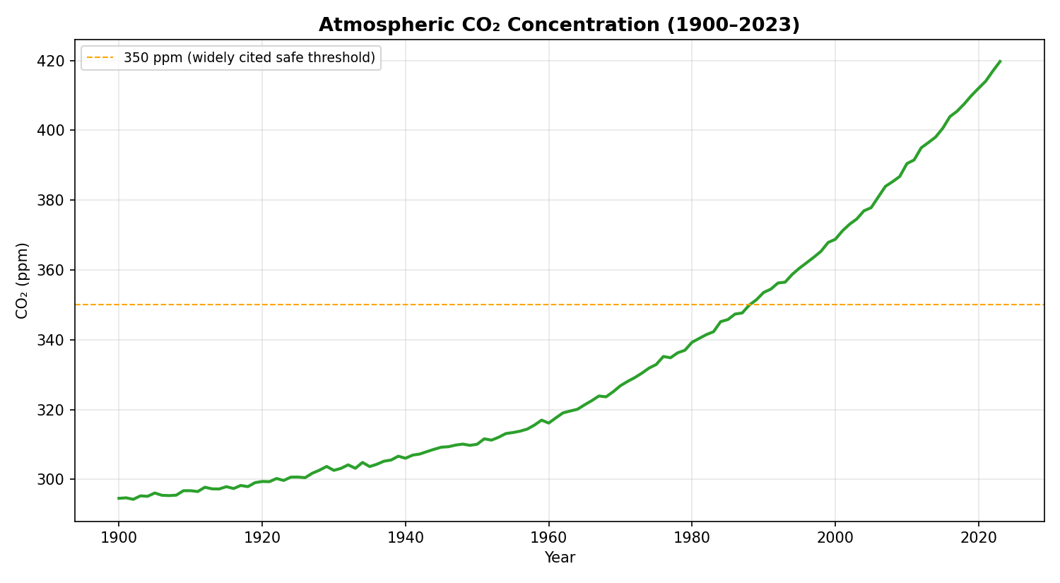
Figure 3.2 — Atmospheric CO₂ concentration, 1900–2023.
CO₂ concentration rose from roughly 295 ppm in 1900 to approximately 420 ppm in 2023 — a 42% increase — and has been above the widely-cited 350 ppm threshold since the late 1980s.

3.4 Temperature–CO₂ Relationship
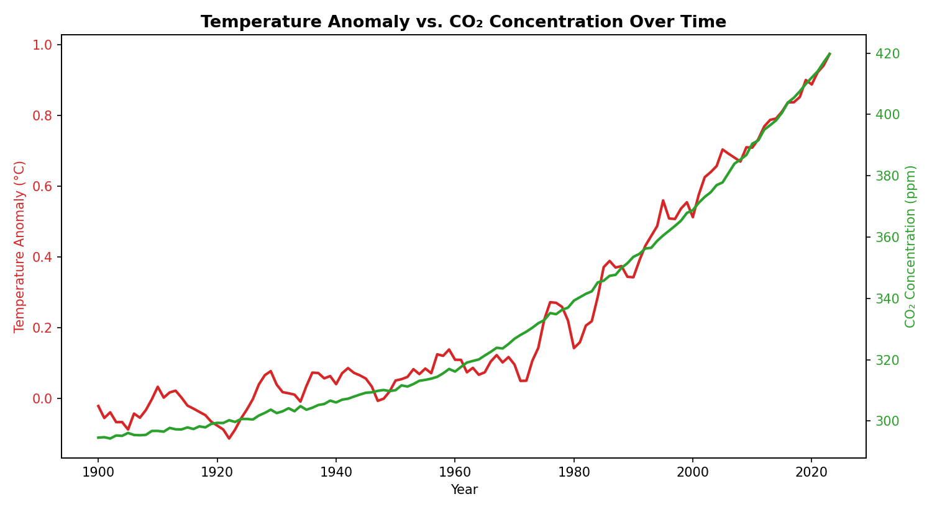
Figure 3.3 — Temperature anomaly and CO₂ concentration plotted together on a dual axis, illustrating their close co-movement (r = 0.95).

3.5 Decadal Patterns
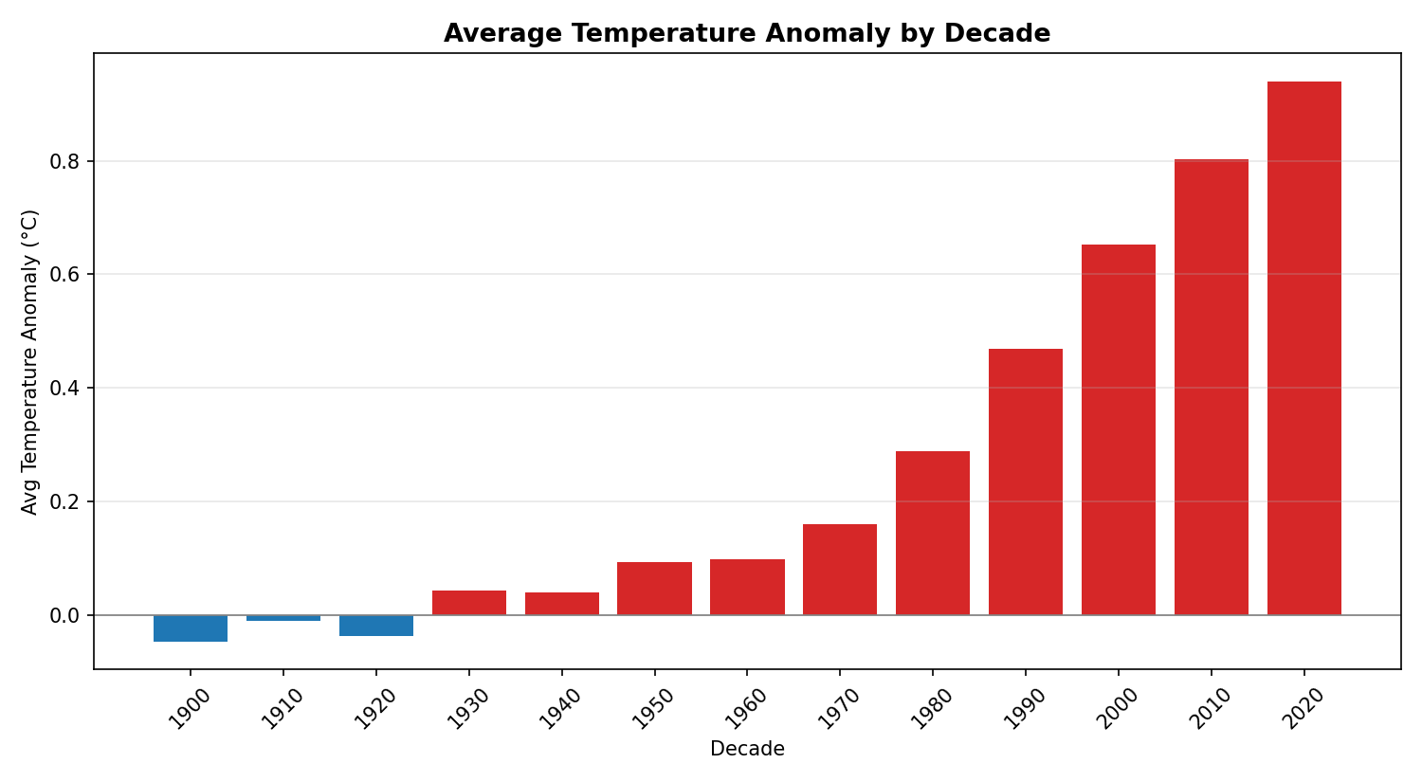
Figure 3.4 — Average temperature anomaly by decade, showing consistent acceleration since the 1970s.
Decade | Avg Temp Anomaly (°C) | Decade | Avg Temp Anomaly (°C)
1900s | -0.05 | 1970s | 0.16
1930s | 0.04 | 1990s | 0.47
1950s | 0.09 | 2010s | 0.80
1960s | 0.10 | 2020s | 0.94

3.6 Key Findings
- Global temperature anomaly and CO₂ concentration are very strongly correlated (r = 0.95) across the full 1900–2023 record.
- Warming has clearly accelerated: the average anomaly increased by only ~0.15°C between the 1900s and 1970s (70 years), but by ~0.78°C between the 1970s and 2020s (50 years).
- The 2020s decade average (+0.94°C) is now approaching the 1.0°C mark relative to the pre-1975 baseline period, with individual years already exceeding +1.0°C.
- 1998 stands out as a statistical outlier year, illustrating that natural variability (e.g., El Niño/La Niña cycles) can temporarily amplify or mask the underlying warming trend in any single year — a reason to rely on multi-year smoothing rather than single-year readings.

3.7 Recommendations
- Communicate climate trends using decadal and multi-year smoothed averages (as in Figures 3.1 and 3.4) rather than single-year figures, to avoid misleading conclusions driven by natural variability like El Niño.
- Given the tight coupling between CO₂ and temperature, prioritize emissions-reduction policy evaluation using CO₂ concentration trajectory as a leading indicator of future warming.
- Track the rate of decadal change (not just the absolute anomaly) as an early-warning metric, since the acceleration itself is the most policy-relevant signal in this data.
- Extend this analysis with regional breakdowns and precipitation/extreme-event data to support localized climate adaptation planning.

Appendix: Methodology Notes
All three analyses follow a consistent pipeline: (1) data acquisition, (2) cleaning and handling of missing values, (3) exploratory analysis including trend and seasonal decomposition, (4) correlation/relationship analysis between key variables, (5) anomaly/outlier detection, and (6) visualization and findings synthesis. Charts were produced with Python (pandas, NumPy, Matplotlib).
To move from this demonstration to a submission-ready report: replace the generated datasets with live pulls from Our World in Data (COVID-19), the World Air Quality Index Project or a national open-data portal (air quality), and NASA GISTEMP or NOAA's climate data records (climate), then rerun the identical cleaning, analysis, and charting code against the real data.

